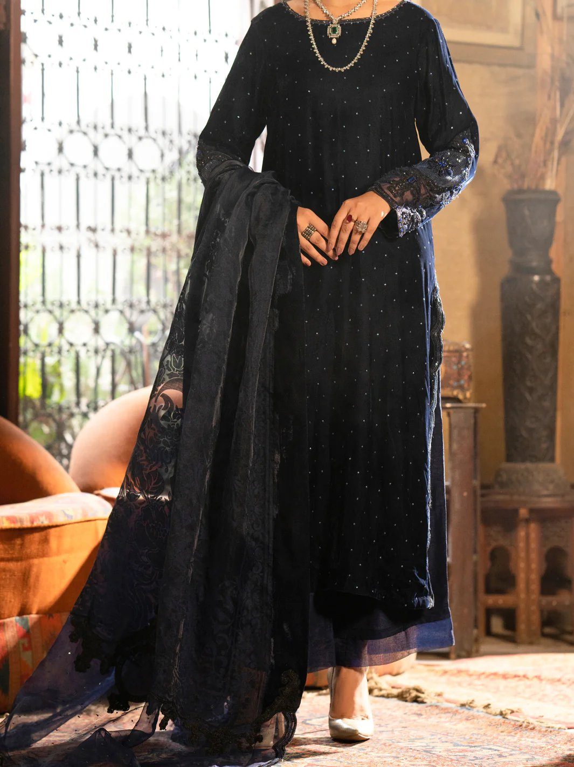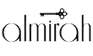

# DARK BLUE VELVET 3 PIECE FORMAL STITCHED - AL-3PS-LS-444

Regular priceRs.27,450.00

ADDITIONAL INFO

|  |  |
| --- | --- |
| **Color** | Dark Blue |
| **Pieces** | 3 Pieces |
| **Fit Type** | — |
| **Fabric** | Velvet, |
| **Season** | Winter Collection |
| **Disclaimer** | Due to the photographic lighting & different screen calibrations, the colors of the original product may slightly vary from the picture. |